Title
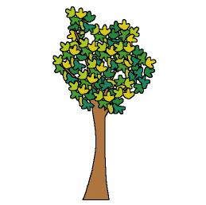

My tree’s diary

We work on

Respect
- Caring
- Observation
- Enjoyment of Nature activities
Activity development

Each child must pay attention to a tree he/she can observe very often (a tree in the school, in his/her house or in any place he/she has contact with). They also have to investigate what is its name and add something else to the name; for example: happy apple tree or Peter pear tree, ...

They have to have a folder, in which they can keep all the information they get about “their” trees:

- A drawing of it
- A drawing of its fruits or seeds
- A leaf of the tree glued on a thin cardboard
- The “print” of the tree: place a paper leaf over the bark of the tree, and rub it with a crayon.

Throughout all the year the children have to observe the variations the tree is undergoing and draw them.

Each child will tell his/her mates what he/she has found out about the tree and lend his/her folder to the rest of the group in order they can also learn about that tree.

P.D.: The eldest children can write a poem about the tree and keep it in the folder. Teachers must help them to write it.

