Title
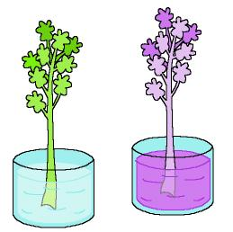

This plant is poisoned!

We work on

Observation
- Appreciation of the well cared environments
- Initiative in Nature preservation
Activity development

The teacher tells the children:

Today our pet has told me that we have to be very careful with the food we take and with the water we drink. If the water and the soil are dirty or poisoned with polluting products, the animals and plants that live in that area can also be contaminated and, as we eat them, perhaps we can be poisoned and become ill, too.

Let’s make an experiment so that you can understand better what happens.

We need:

A glass of water
Some watercolours or colouring matter
A branch of celery.

Each child will drop some watercolour or colouring into his/her glass of water. Then everybody will introduce the celery into the water too. At the end of he day we will observe what has happened.

The celery has changed its colour because it has drunk the contaminated water. Now it is also contaminated.

If we dump garbage into the rivers and lakes, the water will become poisoned and it will poison the plants and animals that drink it.

