Title
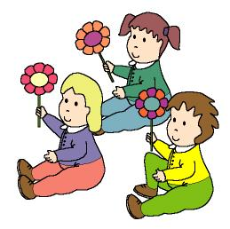

Country flowers

We work on

Nature defence
- Initiative for Nature preservation
- Care for Nature
Activity development

Print file 4c_01.doc and hand it out.

Colour the flower and cut it up; with a drinking straw or an ice cream stick we will make the stem.

Once the flowers are finished, the children will spread over the classroom, raising their flowers.

The teacher plays music, and the children move their flowers according to the music, as if they were moved by the wind. Some children will be “flower-cutters”, and when the music stops they have to root out the flowers of the children who are around them. When the music starts again the children who still have flowers will move them, and the “flower-cutters” will move around these children. When the music stops once again, the “cutters” will root out the rest of the flowers. Then all the children will recite:

Flowers give us
life and colours.
Don’t root out the flowers
please!

The “flower-cutters” will apologise and give the flowers back to their owners, kissing them. When all the children have their flowers again, all of them will dance the “flowers dance”, according to the music the teachers decides to play.

P.D.: Some music we suggest: “Vivaldi: The four seasons (Spring)” or “Grieg: Dawning in Peer Green”.

Supplementary material:
-Flower: file word: 4c_01.doc

