Title
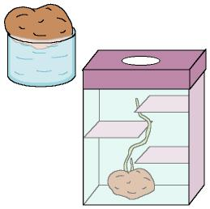

Mrs. Potato

We work on

Caring
- Observation
- Enjoyment of Nature activities
Activity development

The teacher will bring several potatoes to the classroom. He/she will show the potatoes to the children, and will let them to touch and smell the potatoes, to compare their sizes and colours, etc. Then he/she will ask:

- Who likes potatoes?
- How does your parents cook them?
- How often do you eat potatoes?
- Any of you know where the potatoes are grown up?
- As you can see, potatoes are very important in our lives; everybody likes them, and there are a lot of ways to cook them.

Some experiments to observe the growth of the potatoes:

1st We place a potato over a recipient full of water, in such a way that the potato is in contact with the water. Then we place the whole thing in a dark and cool place (somewhere like a wardrobe). We will have to observe the changes as the time goes by. After a few days the potato will have some roots; at this very moment we will have to plant it. A child will water it each day. If our school doesn’t have a small orchard, we can plant it in a wooden drawer in the playground.

2nd Labyrinth: we prepare a cardboard box with a hole in the upper cover (light will enter through it). Inside the box we will built a kind of stairs made with cardboard. Inside the box, at the bottom, we will place a potato that has shoots. Each day we will observe the growth of the potato and we will notice that the small branch has grown up sorting the steps, looking for light.

