Title
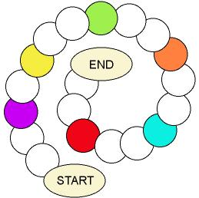

From petal to petal

We work on

Respect
- Caring
- Defence

Appreciation of the environment
Activity development

On a very big mural or even on the ground the teacher will draw a table (see illustration) and will prepare some coloured cards (six cards of each colour). He/she will write three right actions and three wrong actions about the care of plants on each group of cards. Then he/she will order the cards according to their colours (the six cards of one colour will be together).

Children must be split up in five groups; each group must have a leader in order to represent the rest of the group. Leaders will be “tokens” of their groups. They have to stand in the first box. Each team will cast the dice in turns (the dice only represent punctuation from one to three); the leader moves forward as many boxes as the punctuation of the dice. If the leader stops in a coloured box, the teacher will read a card of that colour, and the children will have to guess if the action the teacher has read is right or wrong. If they give the right answer, they will move forward two more boxes; on the contrary, if they are wrong, they will move backward a box. Meanwhile, the rest of the members of the groups must animate their leaders. The winning team will be the one whose leader reaches first the finishing line.

Some examples about right and wrong actions:
To root out the plants
To step on flowers
To observe the plants and water them if necessary
To play with the ball amongst the flowers
To place the plants in a breezy place of the house
To root out the weeds of our orchard
To fertilise the plants

P.D.: Actions on the cards must be known by the children; we will decide what to write according to the age of our pupils.

