Title
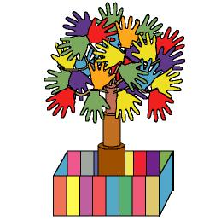

The day of the tree
-The joined hand tree-

We work on

Collaboration
- Caring
- Defence
Activity development

The teacher will say to the children:
Today we are going to build a tree, which will be formed with all our hands. The leaves symbolise our hands; hands that are joined and that work together to protect the environment.

These are the steps to follow:
- Pick up some dried branches or ask the children to bring them from home.
- Prepare cardboard cylinders for the children to colour them.
- Once the cylinders are coloured, put them one beside each other, forming a block. If they have different diameters, place them from the one that has the widest diameter to the one with the shortest one.
- Make holes in the cylinders and introduce the dried branches or some sticks trough them, as if they were the branches of a tree.
- Give to each child the silhouettes of the leaves (file word: 4c_07.doc)
- Put the tree in a cardboard box as if it was a flowerpot.
- Write the name of the child who has made the leaf on it.

The children are split up into small groups. Each group will colour the cylinders in brown (they will form the trunk of the tree). They will also colour the leaves (they can print them with their hands, using watercolours) and cut them up. Finally, they will glue the leaves on the tree branches, folding them by the central part.

Each child will colour a section of the flowerpot in a different colour to decorate it.

When all the process is finished, everybody will form a circle around the tree, hold their hands and sing a song to celebrate the creation of the day: the day of the joined hands tree.
Supplementary material:
-Leaves: file word: 4c_07.doc

