Title
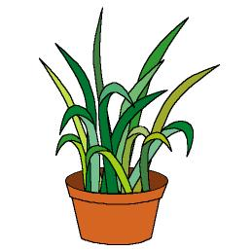

Our classroom is full

of life

We work on

Caring
- Observation
- Responsibility

Enjoyment of Nature activities
Activity development

Each child will bring a plant to the classroom. He/she will show the plant to his/her mates and tell them what kind of plant it is, how it needs to be cared, if it will have flowers, etc.

Everybody will chose a name for his/her plant and tell the rest of the group why he/she has chosen that name.
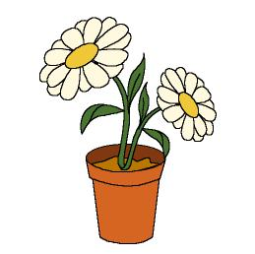
The teacher will help the children to look for an appropriate place for the plants. He/she also will help the children to take care of the plants: they will have to water them, to observe if the plant has light enough, to root out some weeds that are born around them, etc.

In a very big mural children will draw their plants, and the teacher will write the names of the plants below the drawings. The mural will also decorate the classroom, as well as the plants.

