Title
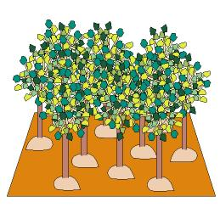

Save the forest!

We work on

Appreciation of the environment
- Caring
- Respect
- Defence
Activity development

The teacher tells the children a story. The situation takes place in a forest (he/she can show them a picture of a forest in which they can see a lot of plants and trees):

Trees live in the forests; and some insects, birds, snakes, mice, squirrels... live in the trees. Trees are their home.
Besides, a lot of necessary products are obtained from the trees. We can get wood to build houses from them, pieces of furniture, pencils, paper, resin to make glue... But we can’t cut down the trees without rhyme or reason. Do you remember when we formed the Club that I told you that the Earth was ill because the trees were being cut and burned and because the entire planet was very dirty? That can’t continue in this way.
You also have to know that trees are “wizards”; they convert the dirty air in clean one. Besides, if the woods and forests are destroyed, all the species that live in there will disappear too.
Let’s build our forest!

Each child will make a small ball with play dough; he/she will put a ice-cream stick on it. Insert another play dough ball in the upper part, and some toothpicks pricked around it. The child will also cut some pieces of coloured paper and glue them on the picks as if they were leaves.

Everybody will place his/her tree over a wooden or cardboard panel (pressing on the small ball to keep the tree standing).

Put the scale model in a central place in order that all the children can see it. All of them will have to decide a name for their forest.

P.D.: If possible, this activity should be carried out in all the classes at the same time; in this way, we will be able to prepare a small exposition when all the forests are ready.

