Title
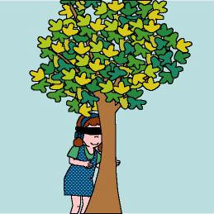

Guess the tree

We work on

Caring
- Enjoyment of Nature activities
- Observation
Activity development

We will be in the playground or in a close park to carry out this activity. There must be several trees or plants that can be explored by the children. The children will work in couples. One of the members of the couple will be the guide, and the other one will be the “blind person” he/she will have his/her eyes covered with a handkerchief or something like that).

The guide will lead his/her mate through the park or playground to a place where there is any tree or plant.

The “blind child” will explore the tree with his/her hands and try to figure out how it is. When he/she thinks it’s enough, the guide will lead him/her again to the starting point. Then the “blind child” uncovers his/her eyes and observes the trees (or the plants) and tries to guess which one has been the tree he/she has been exploring.

Now the guide becomes “blind child” and vices versa. When both have recognised their trees, they will draw them and glue the drawings on the mural of the classroom. The children will observe the tree all the year long; if the tree suffers any modification the children will have to draw it again and put the new picture beside the old one. In this way they will learn about the different periods the tree goes through.

