Title
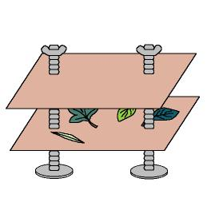

The herbalist’s shop

We work on

Initiative for Nature preservation
- Observation
- Responsibility
Activity development

Before doing the activity with the children we have to ensure that we have a dryer press; it can be built by the teacher or by any volunteer parent. Only two wooden panels and some long screws and wingnuts will be needed. The panels will have small holes to introduce through them the screws, which will be seized with the wingnuts (similar to the picture).

Children will pick up some leaves, flowers and plants in an excursion we organise. The teacher must point out to the children that they only have to take one leaf of each type and must try not to hurt the plants (they don’t have to root out the plants).

The teacher will bring some cloth bags in which the children will keep the leaves and flowers they have picked up.

It’s the moment to star with the sheen. First of all we will compile information about the plants we have some samples from: their names, what kind of plants they are (a tree, a bush or grass), etc.

The children will put the different samples on the press, separating one from each other with absorbent paper (we can also use pages from a newspaper). When we have all the samples in the right place, we will press them and put them in a dry place.

From time to time the children check the state of the samples, changing the pieces of paper if necessary. When they are dry, we will glue them on a mural, where we will also write their names. The children will colour the distinguishing mark according to the plant origin (open file word: 4_06.doc). When we have all the information ready, we will protect the mural with some transparent paper.
Supplementary material:
-Distinguishing marks: file word: 4c_06.doc
