Title
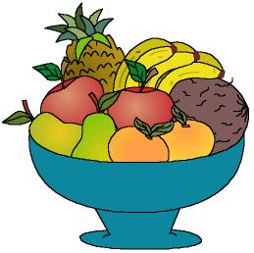

I like this fruit salad!

We work on

Appreciation of the aliments that we get from the plants
- Use of courtesy rules
Activity development

We will ask the children to bring a piece of fruit from home.

Each child will show the rest of the class the fruit he/she has brought and say its name.

The children will smell the different fruits and they will compare their sizes and their texture. We will ask them if the know which fruits come from a plant and which ones come from trees, etc.

The teacher will talk about the importance of the fruits in our lives. And this will be another reason to take care and respect the plants.

The children will wash their hands, and they will help the teacher to peel all the fruits and to cut them in small pieces. They will taste a small piece of each fruit; with the rest of the pieces they will prepare a fruit salad.

The teacher will ask some children to go to the kitchen of the school to ask for plastic glasses or bowls and some teaspoons.

When everybody is in the classroom again, some children will serve the fruit salad for all of them.

When they finish their salad they will clean the bowl and the teaspoon they have been using and will give them back to the cook saying to him/her “thank you”.

