Title
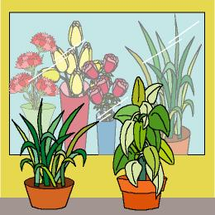

Plant shop

We work on

Caring
- Observation
- Respect

Activity development

Visit a plant shop or a tree nursery.

If you can’t visit any of these places perhaps a market can work; a lot of times we can find some markets-stalls with plants and flowers in them.

When you are there, you must ask the person in charge about the plants he/she has, which ones of them must be indoors, which ones have deciduous leaves, which ones have leaves all the year long, what cares they need, etc.

Once in the classroom again, you will prepare a plant shop with the children:

Form groups of about five or six children each. Each group will lead one stand. The members of each group will make flowerpots with several kinds of plants with play dough of different colours. Some plants will have flowers, some of them will be cactus (we can use toothpicks for this), and some others will have only leaves...

Another option is to look for pictures and illustrations of plants in magazines, cut them up and glue them on thin cardboard. The children will write the name of the plants beside the correspondent picture and decide about the kind of care all the plants need. Then they will put the murals on the table as if it was a shop window.

All the children will “go shopping” to all the stands and they will ask the “employees” about the names of the plants, the care they need, etc.

