Title
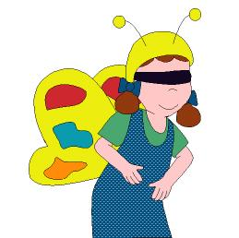

Yummy!

We work on

Caring
- Respect
- Appreciation of natural elements

Activity development

Butterflies, bees and other kind of insects like the plants because these bugs obtain their food from them (nectar from flowers is a very appreciated food item).

Some children are flowers and the others are insects. Insects (who have their eyes covered with a handkerchief or something similar) have to look for the flowers. Flowers imitate the sound of a bell to help the insects to find them.

When insects find the flowers they will stand beside them.
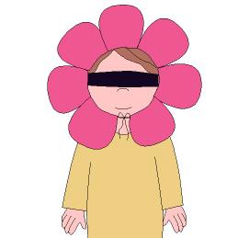

When all the insects find a flower everybody holds hands, making a circle.

Each child, according to his/her place in the circle, will tell his/her mates which flower he/she would like to be, what colour would the flower be and why, where he/she would like to be and how he/she would like to be treated from the people who would visit him/her.

