Title
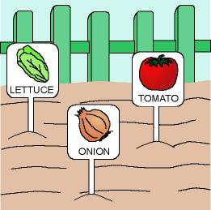

The orchard

We work on

Caring
- Respect
- Initiative in nature preservation
- Enjoyment of nature activities
Activity development

In the right place of the playground we will build an orchard (that place has to receive as many hours of sun as possible and be protected from cold and humid winds). Delimit the area with fences or with sticks and strings, in order to avoid stepping on it. Both, teacher and children will decide what kind of plants they are going to plant in each season of the year. They will also decide about the responsibilities of caring for the garden.

Prepare the land, clean it from weeds, garbage and stones; turn over the land to ventilate and soften it. Improve the water drainage. When the land is dry, break the clods into small pieces, mixing the land with the fertiliser (just in case you have used it).

Prepare some mounds on the land with trails on the sides intended for the water to drain and for walking on them when cultivating. If possible, put some carpet squares on them. Prepare orchard seeds, of which eatable parts are obtained from:

The root (potatoes, carrots, onions, garlic, …)
The leaf (lettuces, silver-beets, …)
The flower (tomatoes, peppers, …)

Each group will prepare and sow a type of plants; they will also elaborate some cards with the drawing of the plants that have been sowed and place them on the seedbeds, to distinguish those seeds from the rest. According to the plan, the children will water the area, they will root out some weeds, etc.

When you recollect the products, the children will bring them home.

P.D.: If there is no chance to build an orchard, seeds can be sowed in big wooden drawers (one plant in each drawer.

