Title
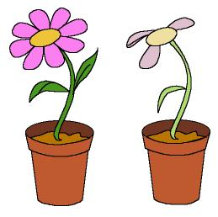

Don’t be sad

We work on

Observation
- Initiative
- Defence

Activity development

The teacher shows the children a flower that is shrivelled. Then he/she asks them why do they think that flower is in that condition.

Print file word: 4c_05.doc, and give one illustration to each child. When they have observed the picture, ask them:

- What can you see in the picture?
- Which flowerpot is your favourite?
- What has happened to this flower? (Pointing to the one without petals).
- Why doesn’t it have any petals?
- What would we have to do to keep this flower as strong and healthy as the other one?
- Don’t you think it’s sad? Why don’t we draw its petals and colour them?

At this moment the children draw the petals and colour them.

The children paint their hands with green watercolour and they stamp their handprints on a mural, as if the prints were grass.

Cut the flowerpots with the flowers and glue them over the grass on the mural.

The children observe the classroom and decide which place in it is the saddest. That place will be the one in which you must hang the mural, to give it happiness and colour.
Suplementary material:
-Flowerpots: file word: 4c_05.doc

