Title
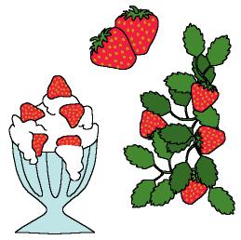

Vegetables

We work on

Appreciation of plants as food for us
- Respect

Activity development

Each child must bring some food obtained from a plant; besides, he/she has to bring a drawing of the plant and a easy recipe we can prepare with that food (if we are working with young children we will write a note to their parents asking them to collaborate with their children on the drawing and the recipe).

Each child will show the rest of the group the food and the drawing he/she has brought, while saying its name.

The teacher will ask the children about:
- The different dishes that can be prepared with them.
- How do their parents prepare those foods?
- What are their favourite ways to eat them?
- If there is any item they don’t like amongst the ones they have brought.

The teacher will comment on the importance of the plants as food for us and also on the benefits we can obtain from them.

The children will make a book about vegetables. Of course, the teacher will help them:

- Glue each drawing on one page of the book and write the name of the plant.
- The teacher will help them to write the recipes; they can add some illustrations or drawings to it.
- Glue some pictures of vegetables that appear in magazines or catalogues from supermarkets.
- Decorate the covers of the book with printings from the food they have brought (they have to be damped in watercolours for this).

