Title
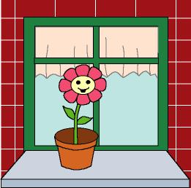

The lost seed

We work on

Caring
- Observation

Responsibility

Activity development

We will tell a story:

Paul used to live in a very beautiful house that had a wonderful garden decorated with a lot of flowers. Some of those were still seeds, prepared to bloom.

One of them -we don’t know how- was left out of the soil, in a place close to a fountain. The time went by, and the seed was more and more ill, because it hardly ever was watered (it only received some drops from the fountain from time to time). It was not going to grow and become a beautiful flower if it continued in the same way.

One day, while Paul was playing in the garden, he saw the seed and thought: “It would be better if I took care of this seed at home; if I do this, it will become as strong as the others”. So he took a small flowerpot and put some soil in it; then he introduced the seed in it to keep it warm. Everyday, when Paul got up, the first thing he did was to water his seed. A short time later, a small green branch appeared, and it began to grow faster and faster.

Paul got up one day and his happiness was huge when he saw a small flower appearing from the green branch. The flower was smiling at him. From that day the flower was never sad again, because it knew it had a friend who took care of it and gave affection to it.

When the story is finished, the teacher will ask the children:
Why was the seed sad?, What did Paul do when he saw it?
What did he do to take care of the seed?, What happened some days after the seed was
seen by Paul?

The teacher will give the children some fast-growing seeds. Each child will plant his/her seed and will take care of it.

