City throw

Once upon a time there was a city called Throw. It was a place where everybody throws the rubbish on the streets.

One day, the city was covered by so much rubbish and it was very, very dirty. There weren´t any parks, any animals and any plants. People and children were sad and they were ill.

There were three children named Ana, Cindy and John that they were worried about the city. A little bird listened to them and it said:

_”don´t worry, wait a moment and I will help you”.

The children were very happy and they listened to music.

If you want to help

Learn to recycle, recycle, recycle.

Learn to recycle.

Ana, Cindy and John were surprised and they said:

_OHHH WHO IS SINGING? Far way a magician was coming and he said:

_“Hello I´m the recycling magician and I know your problem”.

_ “I¨ll teach you to recycle”.

He said:

_“Plis splass splin the food, here it is”. And a grey container came.

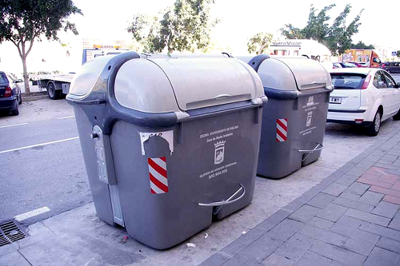

_“Plish Pin, catapí …The paper, here it is”

And one blue container came

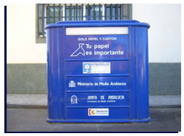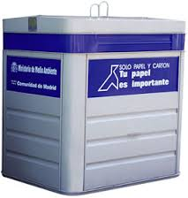

_ Plish, Pin, catapí…I throw the glass and here it is.

And a green container came

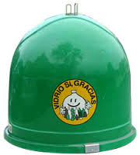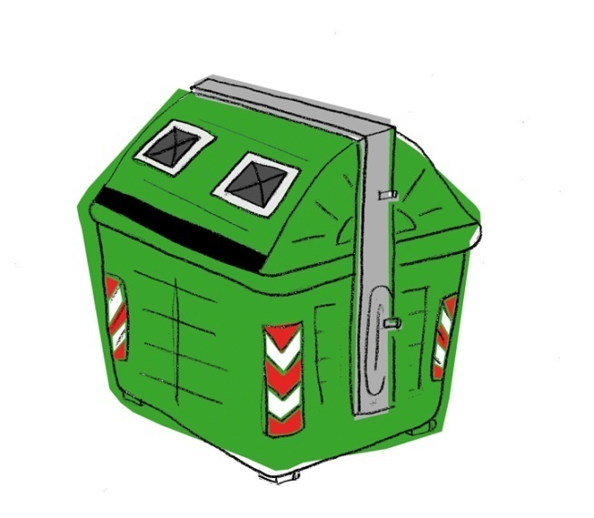

The children were surprised for the magic of recycling

_ Plish pin catapish the plastic, here it is.

And the last container was yellow

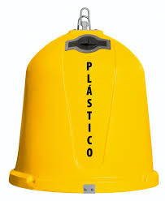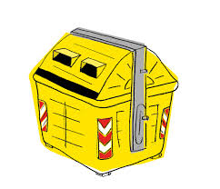

The magician had created 4 containers: One grey for the organic materials, one blue for the paper, one yellow for the plastic and one green for the glass.

And finally he said: Abracadabra, abracadiiii the magic of recycling you will see.

The people of the city started to throw the rubbish on every container.

And they sign a song:

If you want a clean city learn to recycle, the earth is ill and love it

Learn to recycle, recycle, recycle, recycle.

Everybody cleaned the city and they changed the city name, it wasn´t city Throw, now it was the Recycling city.

Author:

Alejandra Rodríguez Expósisto. CEIP Amelia Vega

C:\Users\Alejandra\AppData\Local\Microsoft\Windows\Temporary Internet Files\Content.IE5\WG2GLK0L\MC900318432[1].wmfC:\Users\Alejandra\AppData\Local\Microsoft\Windows\Temporary Internet Files\Content.IE5\Z882FAN9\MC900413384[1].wmf

Oral questions

Pre reading.

Look at the pictures. What do you think is the story about?

Read the topic ( what does it tell you?)

Do you throw the papers in the bin, on the floor?

After reading:

1.- What´s the children´s name?

2.- what´s the city name?

3.- Who visited the city?

4.- What did he do?

5.- Where did they throw the rubbish?

6.- Did they call the city with another name?

Write another name for the city (at the beginning and at the end)

Write another end for the story.

Imagine the city when it was dirty and draw it.

Now imagine the city after cleaning it.

Discuss with our pupils which city is better for living.