Title
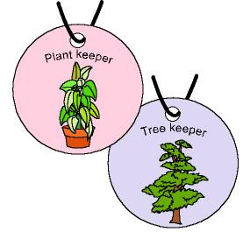

Keeping and protecting

We work on

Responsibility
- Help
- Defence
- Conservation
Activity development

The teacher tells the children:

Today we are going to talk about different jobs, as far as the care of forests, countryside, oceans... is concerned.

Gamekeeper: he/she takes care and protects the animals and he/she impedes the hunters to harm them. They also care for the trees and plants; they observe if the trees are ill, if they need to be pruned... and inform the people about how they have to behave in natural places in order not to spoil them.
Marine guard: they watch the sea; they don’t allow people to dirty the water and to harm the fish.
Nature entertainers: their mission is to teach the children and the adults the elements we can find in natural places.

Following the example of these people, we can also teach people how to take care of Nature, and we also can be guards and keepers of something:

- Playground keepers
- Garden keepers
- Keepers of the flowerpots of the classroom
- ...

The teacher will suggest some responsibilities the children can take; each child will choose one of them, and he/she will make a kind of necklace writing the name of the responsibility he/she has chosen on it. In this way everybody will know which one is his or her assignment.

The children that choose the same responsibility will share the duties

