Title
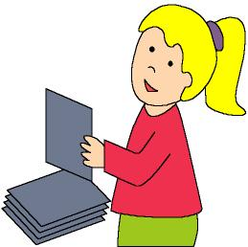

Guess what?

We work on

Observation
- Respect

Caution

Activity development

The teacher has different animal cards that will be disposed upside down on the table. One child takes one of them and looks at it (his/her mates can’t see the card).

Print file 3c_06.doc, 3c_07.doc, 3c_08.doc, 3c_09.doc and 3c_10.doc.

Now the child has to describe the animal: if it has hair, feathers, scales..., where it lives, what kind of food it eats, ... and the other children have to guess what animal is being described.

When they guess the animal, they all will have to imitate the animal. The person who guessed the animal keeps the card with the picture of the animal he/she has guessed, and takes another one to describe it.

When the activity is done, the teacher says:

Now we know plenty of things about these animals, but we have to learn some more; for example, how these animals defend themselves when they are in danger. And we also can learn how we can be careful to avoid the dangerous situations for the animals.

So let’s investigate. All of you will take one of these cards and bring them home with you. Then you will ask your family about the animal in the card.

Supplementary material:
Animal cards: 3c_06.doc
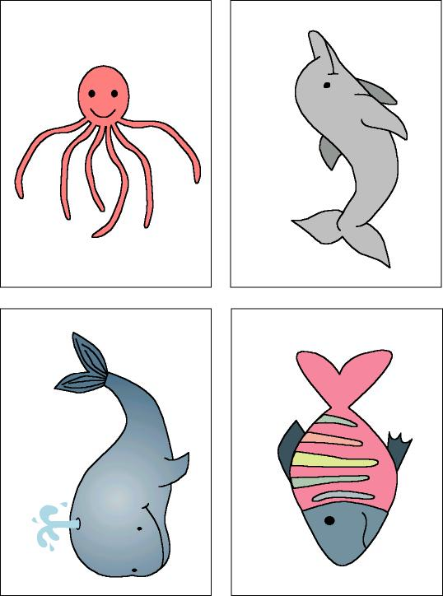

Supplementary material:

Animal cards: 3c-07.doc

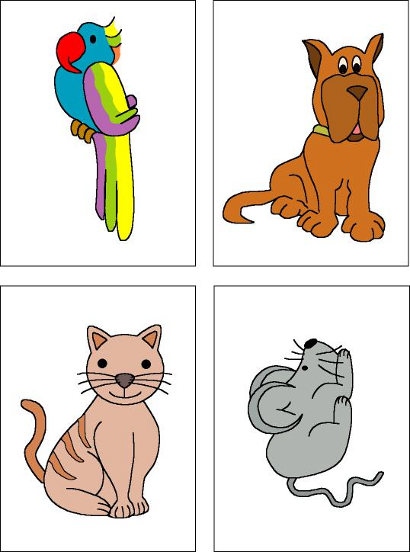

Supplementary material:

Animal cards: 3c_08.doc

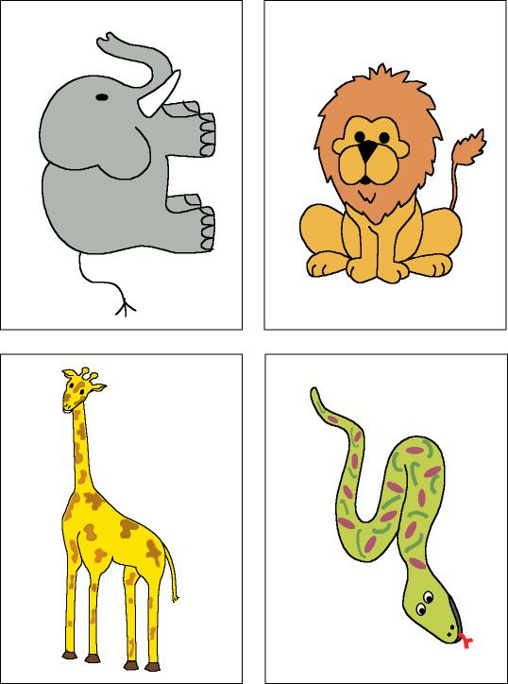

Supplementary material:

Animal cards: 3c-09.doc

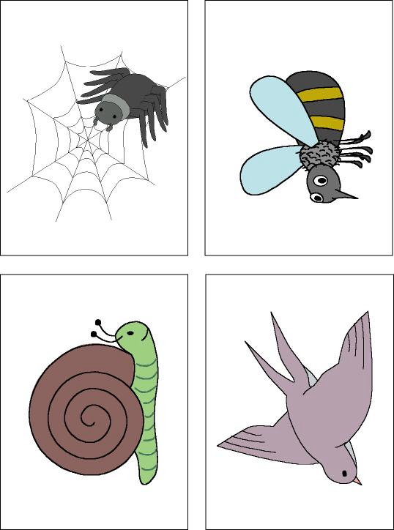

Supplementary material:

Animal cards: 3c-10.doc


